Create an S3 Bucket
Follow these steps to configure and create an S3 bucket in the AWS Management Console:
Step 1: Sign In to AWS
Step 2: Search for Amazon S3
- Go to the search bar at the top of the AWS Console
- Type S3
- Select Amazon S3 from the search results
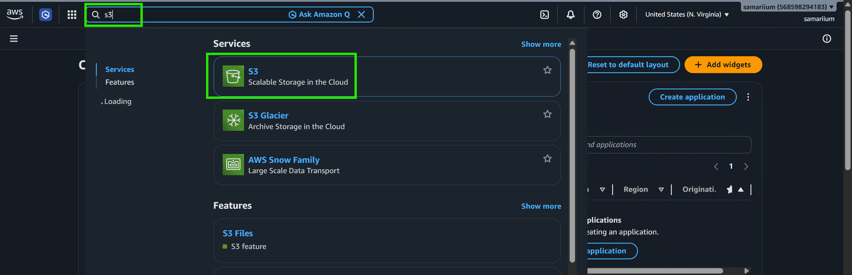
Step 3: Creation of Bucket
- Click on Create bucket
- Select Bucket type "General purpose"
- Select Bucket namespace "Global namepace"
- Enter a unique bucket name
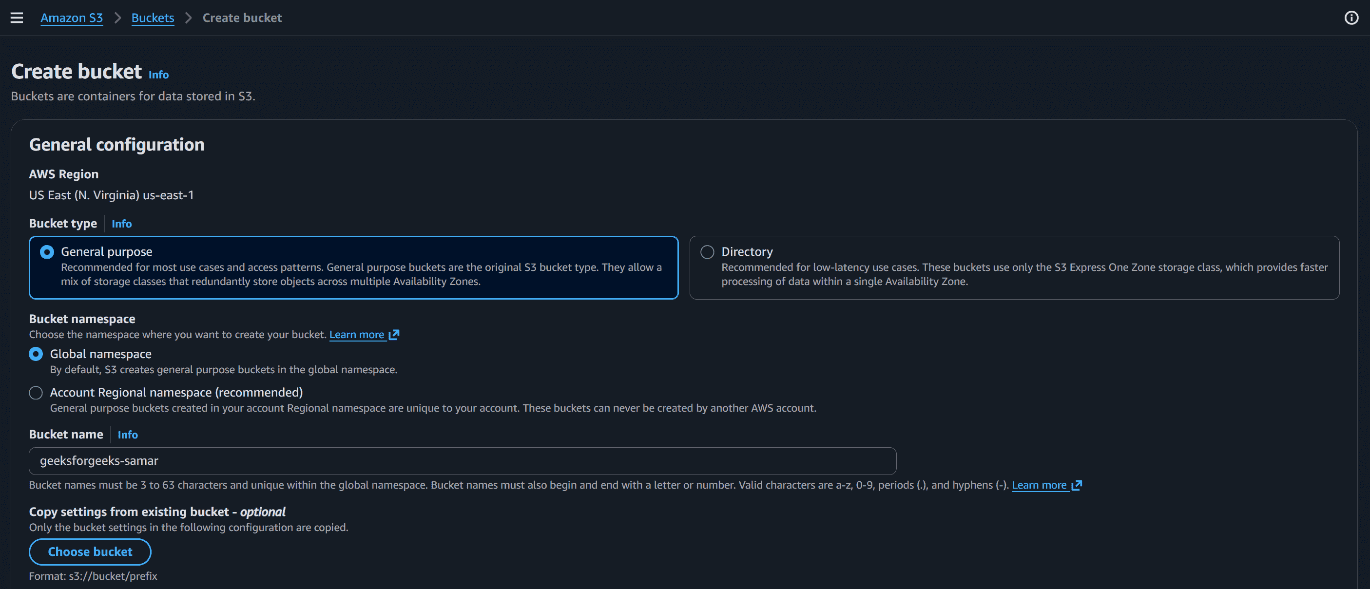
Step 4: Configure Bucket Settings
- Under the Configure Object Ownership Keep the default setting "ACLs disabled"
- Under the Block Public Access Settings keep "Block all public access" enabled
- Leave Bucket Versioning disabled
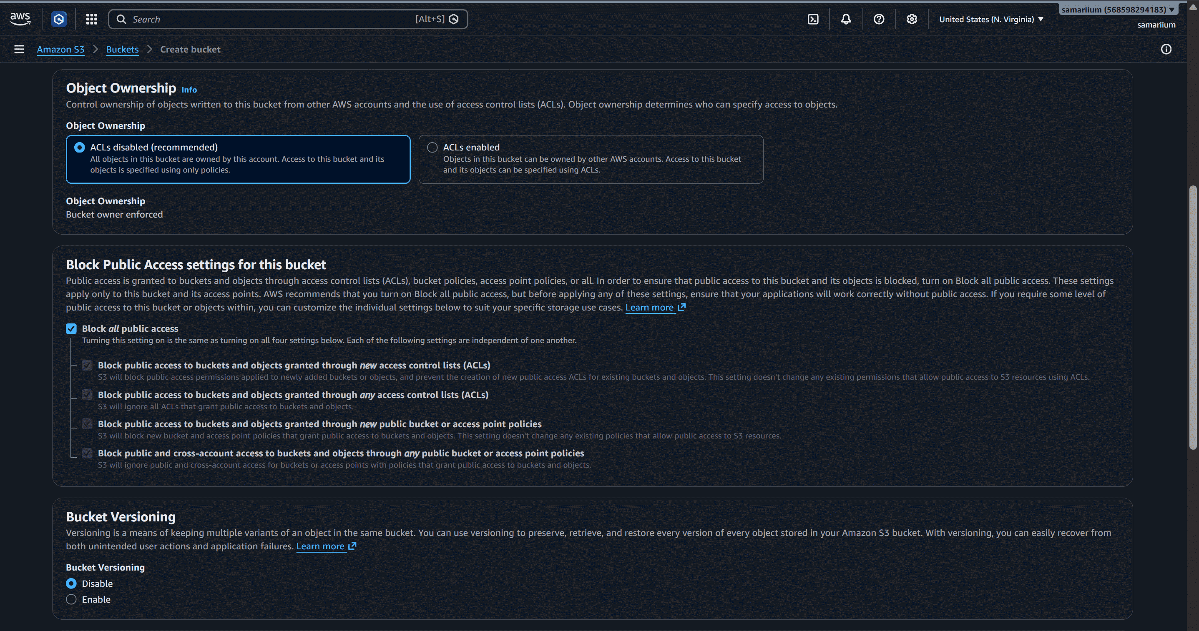
- Review Additional Settings
- Click Create bucket
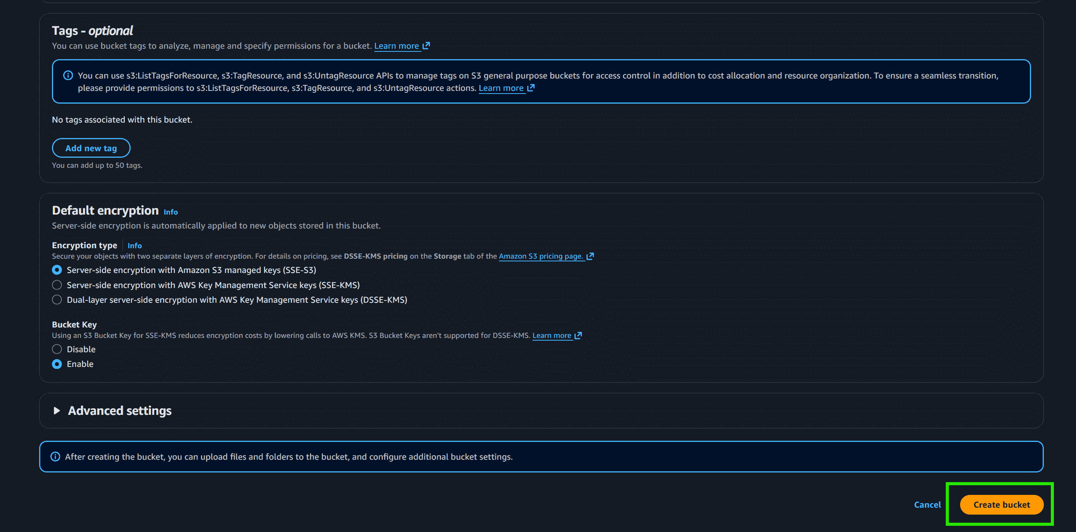
Step 5: Verify the Created Bucket
- Return to the Amazon S3 dashboard
- Under the Buckets section, locate your newly created bucket
